

“Python Experiment no.2”

Name – Pratyaksh Singh
Sapid - 590023001
Batch - B45
Faculty Name – Dr. Amit Ranjan

Q1. Check whether the given number is divisible by 3 and 5 both.
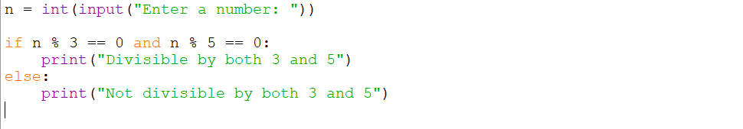
Output –
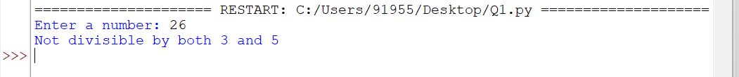

Q2. Check whether a given number is multiple of five or not.
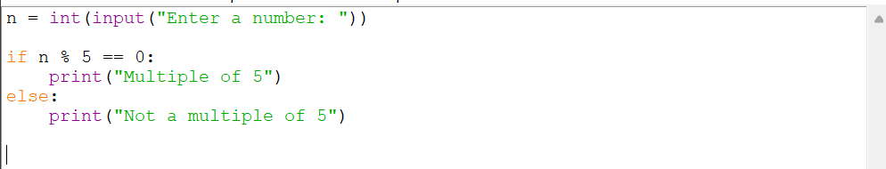
Output –

Q3. Find the greatest among the two numbers. If numbers are equal than print “numbers are equal”.
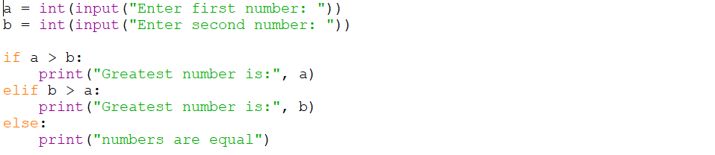
Output(a) –
Output(b) –

Q4. Find the greatest among three numbers assuming no two values are same.
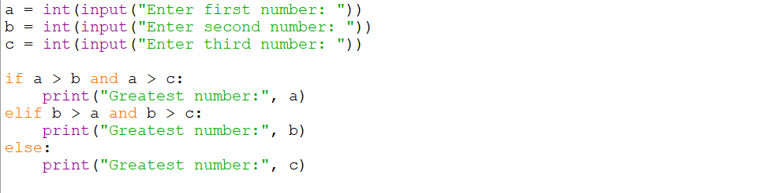
Output –
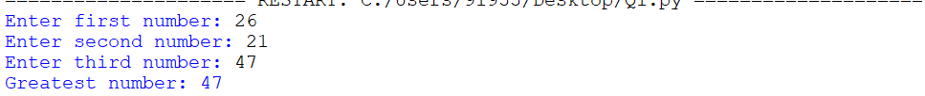

Q5. Check whether the quadratic equation has real roots or imaginary roots. Display the roots.
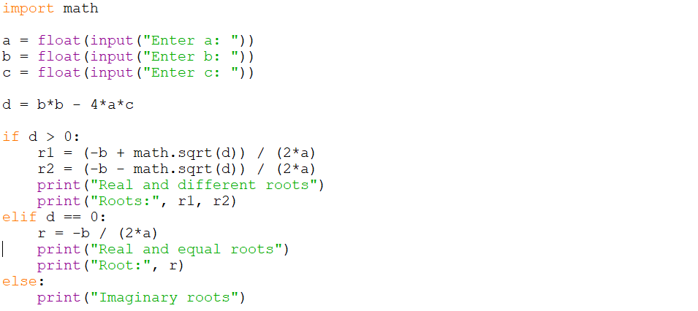
Output –
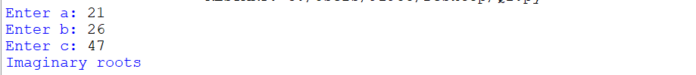

Q6. Find whether a given year is a leap year or not.
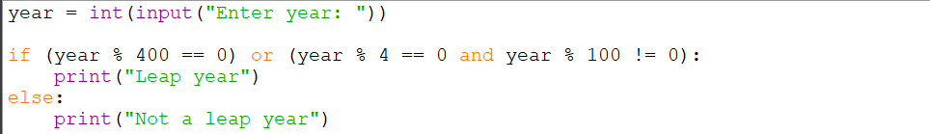
Output –

Q7. Write a program which takes any date as input and display next date of the calendar.
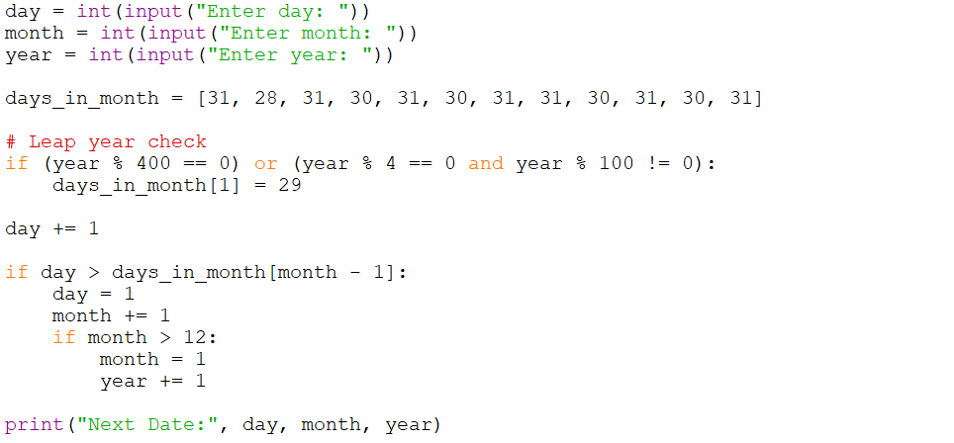
Output –

Q8. Print the grade sheet of a student for the given range of cgpa. Scan marks of five subjects and calculate the percentage.
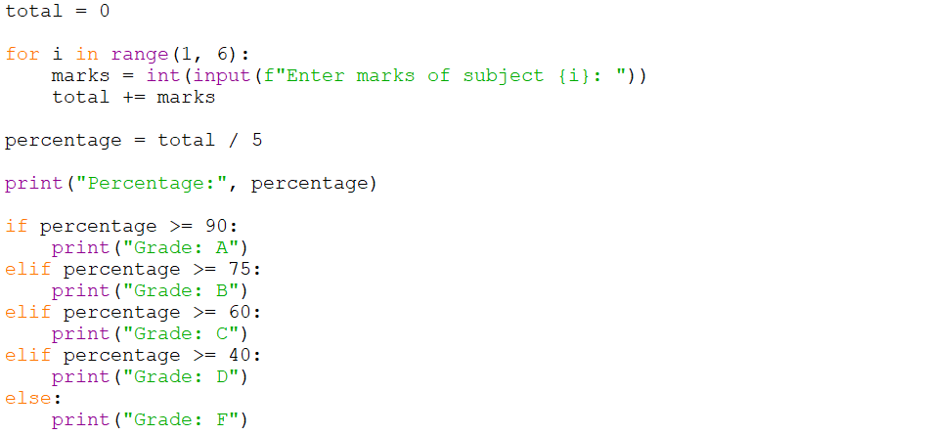
Output –
